2022 Campmeeting
Community Services Project
Oxford School Needs List
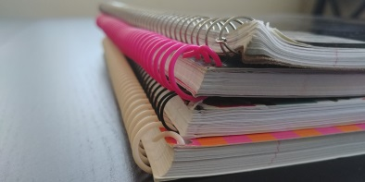
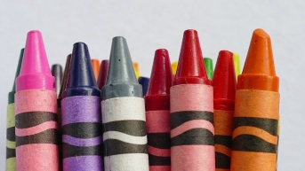
Notebooks - Red, Blue, Green
Crayola Crayons
Crayola Markers
Crayola Colored pencils
Note book binders (1”-1 ½” Blue or Black with clear pocket on front)
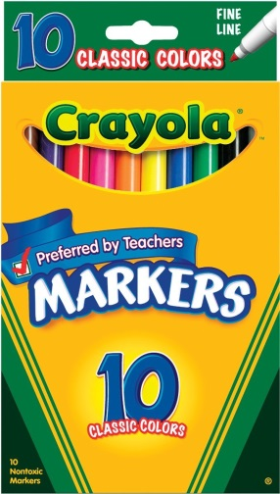
Boys and Girls underwear Size 6 and larger
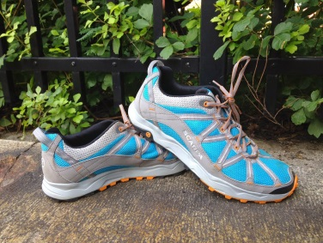
New shoes -- All sizes
Healthy snacks
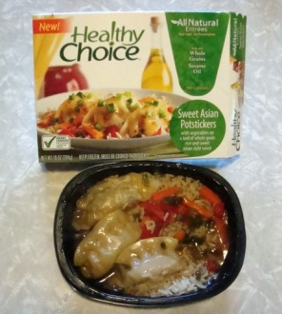
Microwavable food

