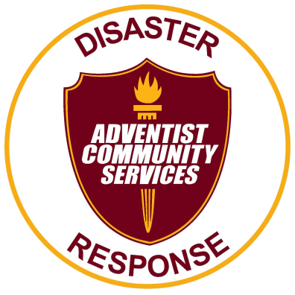
You are invited to be a part of the
Emotional and Spiritual training
September 20-22, 2019
At Camp Wakonda
With Presenter W. Derrick Lea from the North American Division,
This is Part 1 of 2 parts and will be 15 hours of training.

Required Fee: Wisconsin Church Members $50.00 Out of state members: $75.00 includes:
1. Lodging: at Hickory and Red lodge dorm style with maximum of 5 per room, (bring bedding. Each room will have 4 single beds and 1 queen bed),
2. Food: (Friday supper through Sunday lunch),
3. Material required for the class. Manuals, Books, Ect.
___________________________________________________________________________
Please register with payment by September 1, 2019

Name: ______________________ Phone: _________________

Address:_______________________________________

Email: ________________________Fee Included:___________

Send registration to:
Alice Garrett
142 1st Street
Clear Lake WI. 54005

Questions??? Contact Alice Garrett: agarrett@wi,adventist.org or
Phone 608-345-3883

