The LightHouse Thriftstore
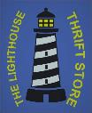
December Specials

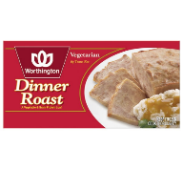
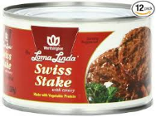
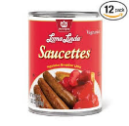

Store hours
Sunday 10am-3:30pm
Monday 10am -5pm
Tuesday 10am - 5pm
Wednesday 10am - 5pm
Thursday 10am - 5pm
Friday 10am – 3:30pm
Closed sabbath
Phone: 920-382-4922
We will be closed December 24th thru January 1st We will return January 2nd at 9am

Worthington Dinner Roast
Sale $12.49 Reg $15.49

Swiss Stake 13oz
Sale $4.99
Case $56.88

Saucettes 19oz
Sale $5.99
Case $68.88

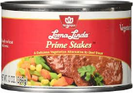

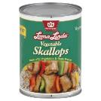

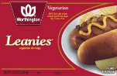

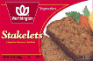

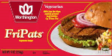

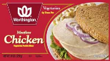

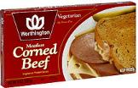
Prime Stakes 13oz
Sale $4.99
Case $56.88

Vegetable Skallops
Sale $5.99
Case $68.88

Leanies
Sale $2.49

Stakelets
Sale $3.89

Fri-Pats
Sale $3.49

Worthington Chicken Slices
Sale $2.99
Worthington CornedBeef Slices
Sale $2.99

